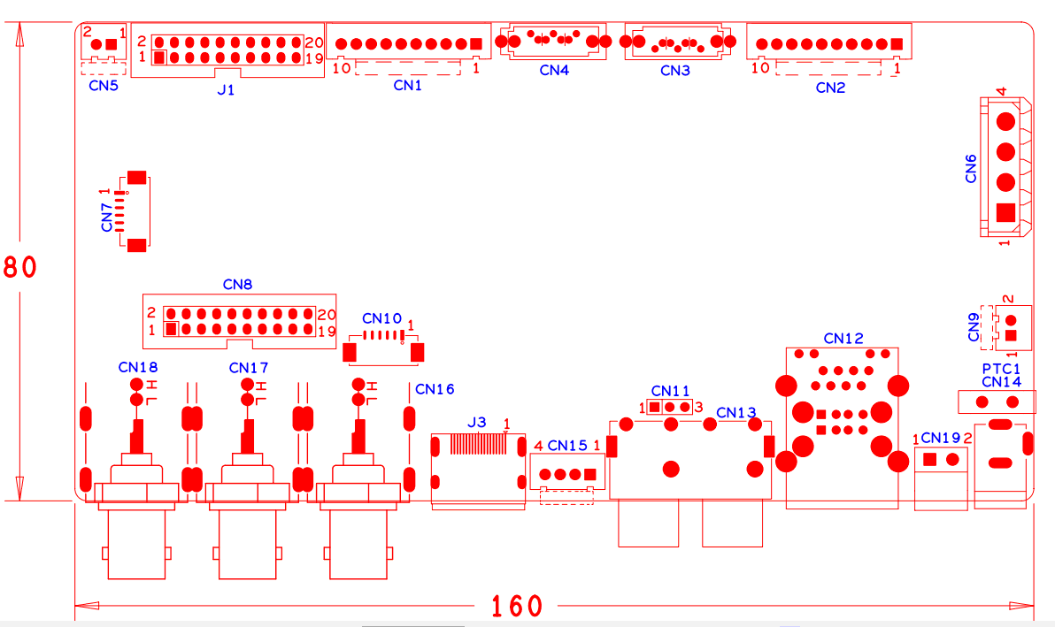

|  |  |  |  |  |  |
| --- | --- | --- | --- | --- | --- |
| 位号 | 功能描述 | 接口定义 | | | |
| CN5 | 风扇电源座子 | 1：+12 | 2：GND |  |  |
| J1 | 20PIN前面板座子 | 1：GND | 2: ROW0 | 3: ROW1 | 4: ROW2 |
|  |  | 5: ROW3 | 6: COL0 | 7: COL1 | 8: COL2 |
|  |  | 9: COL3 | 10: ALARM | 11: REC | 12: IR |
|  |  | 13: LINK | 14: +3.3 | 15: ROW4 | 16: COL4 |
|  |  | 17:NC | 18:GND | 19：NC | 20:NC |
| CN1 | 10PIN不带单片机前面板座子 | 1:+3.3 | 2：GND | 3：IR | 4：COL1 |
|  |  | 5：COL3 | 6：COL4 | 7：ROW4 | 8：COL2 |
|  |  | 9：ALARM | 10：REC |  |  |
| CN4 | SATA接口座子 |  |  |  |  |
| CN3 | SATA接口座子 |  |  |  |  |
| CN2 | 带单片机前面板扩展接口 | 1：+5V | 2：GND | 3：+5_STB | 4:GND |
|  |  | 5:NC | 6:NC | 7:UART_RXD | 8:UART_TX |
|  |  | 9:PWR_S | 10:GND |  |  |
| CN7 | 视频扩展接口 | 1：VIDEO5 | 2：VIDEO6 | 3：VIDEO7 | 4：VIDEO8 |
|  |  | 5：GND | 6:GND |  |  |
| CN6 | 硬盘电源座子 | 1：+12 | 2：GND | 3:GND | 4:+5 |
| CN8 | 音视频报警扩展座子 | 1：GND | 2:+5 | 3: VIDEO8 | 4: VIDEO7 |
|  |  | 5: VIDEO6 | 6: VIDEO5 | 7: AUDIO6 | 8: AUDIO7 |
|  |  | 9:GND | 10:GND | 11: AUDIO2 | 12: AUDIO5 |
|  |  | 13: AUDIO4 | 14: AUDIO3 | 15: AUDIO8 | 16: ALIN1 |
|  |  | 17: ALIN4 | 18: ALIN2 | 19: ALOUT1 | 20: ALIN3 |
| CN10 | VGA扩展座子 | 1：GND | 2: VGA_RED | 3: VGA_GREEN | 4: VGA_BLUE |
|  |  | 5: VGA_HSO | 6: VGA_VSO |  |  |
| CN9 | 风扇电源座子 | 1：+12 | 2：GND |  |  |
| CN18 | 视频输入端子 | 1：VIDEO4 | 2：VIDEO3 |  |  |
| CN17 | 视频输入端子 | 1：VIDEO2 | 2：VIDEO1 |  |  |
| CN16 | 音视频输出端子 | 1：AUDIO_OUT_MAIN | 2：VIDEO_OUT_MAIN |  |  |
| J3 | HDMI接口 |  |  |  |  |
| CN15 | USB扩展接口 | 1：+5 | 2：USB2DM | 3：USB2DP | 4：GND |
| CN11 | 串口座子 | 1：UART0_RXD | 2：UART0_TXD | 3：GND |  |
| CN13 | 音频输入端子 | 1：AUDIO4 | 2：AUDIO3 | 3：AUDIO2 | 4：AUDIO1 |
| CN12 | 2USB+网口组合座子 |  |  |  |  |
| CN19 | RS485接口 | 1：RS485_A | 2：RS485_B |  |  |
| PTC1 | PTC器件 |  |  |  |  |
| CN14 | 12V电源输入接口 |  |  |  |  |
|  |  |  |  |  |  |